RFID Communication Protocol V1.0
1. Product images
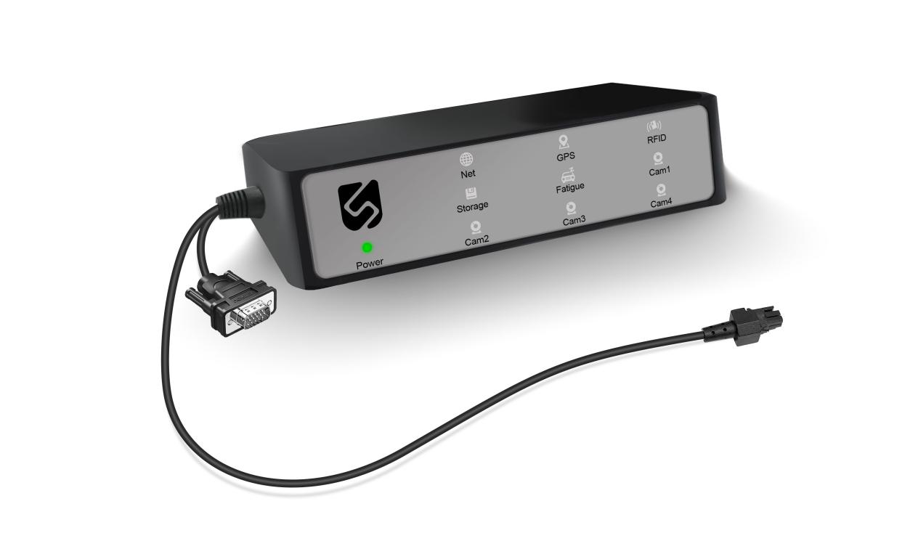
2. Connection diagram
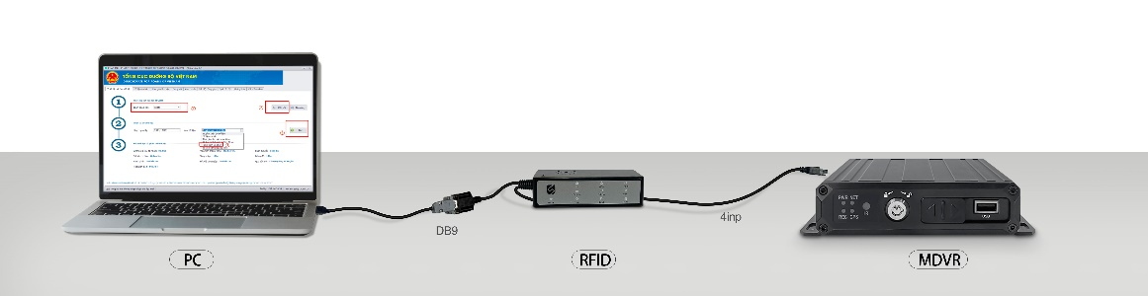
3. Interface definition
RFID card reader connected to MDVR terminal
Baud rate: 115200, no checksum, data bit 8, stop bit 1
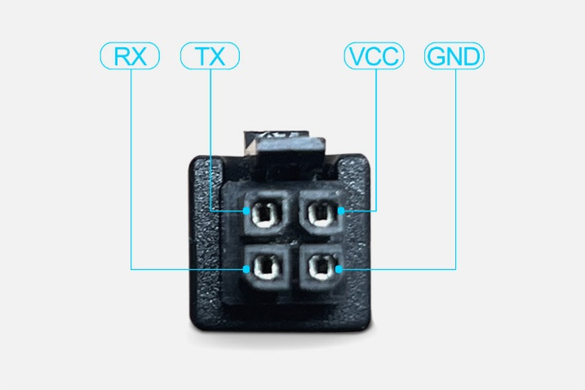
4. RFID card reader connected to PC
Baud rate: 115200, no checksum, data bit 8, stop bit 1
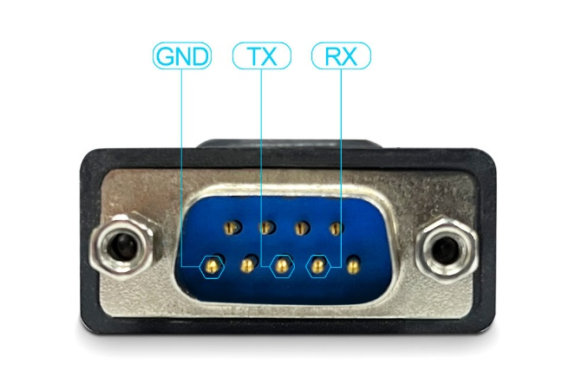
5. Data transmission protocol
Baud rate: 115200, no checksum, data bit 8, stop bit 1

Receive and send data format:
Byte | 0 | 1 | 2 | 3 | N + 3 | N + 4
Format | Frame header (0x7e) | Data type | Data length N |  | Data segment | Checksum
Note: ① Checksum: frame beginning+data type+data length+data segment.
② Data type: Please refer to protocols 1, 2, 3, 4, etc. for details
- Read RFID card number protocol
Data type: 0x00
Data segment format when receiving commands:
Data length is 0
Data segment format when responding to commands:
Obtained card number
Example: Card number: 52 93 A0 02 53 01 04 E0
Sent: 7E 00 00 00 7E
Received: 7E 00 00 08 52 93 A0 02 53 01 04 E0 45
- Read RFID card data protocol
Data type: 0x01
Data segment format when receiving commands:
Byte0: Start block number
Byte1: Number of consecutive read blocks
Data segment format when responding to commands:
Obtained block data
Example: Read the 00th block, continuously read 8 blocks of data;
Sent: 7E 01 00 02 00 08 89
Received:7E 01 00 20 31 32 33 34 35 36 37 39 20 00 00 00 00 00 00 C5 4E 67 75 79 65 6E 20 56 61 6E 20 41 00 00 00 00 45
3. Write RFID card data protocol
Data type: 0x02
Data segment format when receiving commands:
Byte0 – Byte 14: Driver’s license number
Byte15: Check sum of the driver’s licentse number
Byte16-Byte59: Driver’s name
Byte60: Check sum of the driver’s name
Example: Write the Driver’s name is Nguyen Van a with the driver’s license number is 12345679:
Sent: 7E 02 00 3D 00 31 32 33 34 35 36 37 39 20 00 00 00 00 00 00 C5 4E 67 75 79 65 6E 20 56 61 6E 20 41 00 00 00 00 00 00 00 00 00 00 00 00 00 00 00 00 00 00 00 00 00 00 00 00 00 00 00 00 00 00 00 36 99

4、LED light and buzzer control protocol
Data type: 0x03
Data segment format:
Byte0：buzzer
Byte1：led_pwr
Byte2：led_net
Byte3：led_gps
Byte4：led_login
Byte5：led_rec
Byte6：led_alram
Byte7：led_cam0
Byte8：led_cam1
Byte9：led_cam2
Byte10：led_cam3
Byte_Value: The low 4 digit value (0: constant off, 1: constant on, 2: single flashing, 3: continuous flashing), when flashing, the high 4 digits indicate the flashing frequency, flashing several times in 1 second, and the maximum should not exceed 5
Example:
- full leds off:
Sent: 7e 03 00 0b 00 00 00 00 00 00 00 00 00 00 00 8C
No response
- full leds on;
Sent; 7e 03 00 0b 01 01 01 01 01 01 01 01 01 01 01 97
No response

5、Transparent data protocol
Data type: 0x04
Data segment format:
Data to be transmitted through
Sent: 7e 04 00 15 24 47 53 48 54 2c 31 2c 34 2c 3c 31 30 2c 30 3e 2c 31 36 23 00 c7
Received: 7e ff 00 01 01 7f//indicates successful transparent transmission with data type ff

